**TimeSeries Heatmap**

**R. Harini**

**18BCE1010**

**State:** Karnataka

**Dataset:** <https://www.karnataka.com/govt/district-wise-covid-19-cases/>

**Tool used:** Tableau

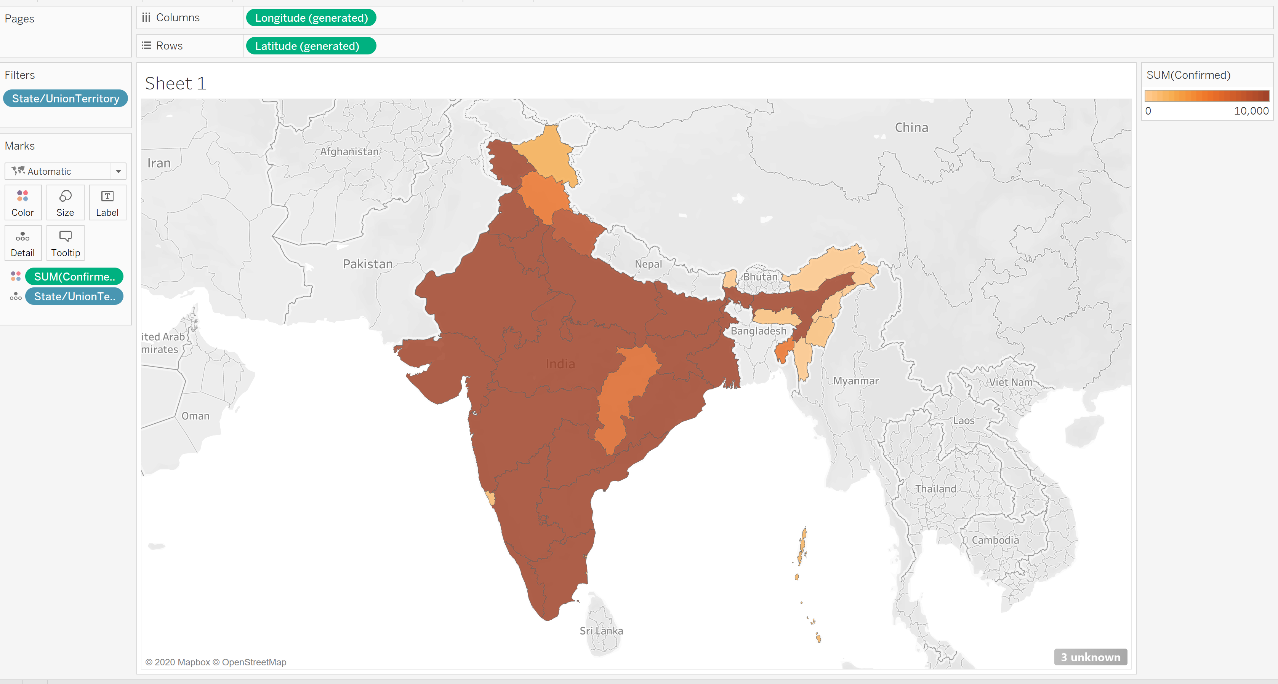

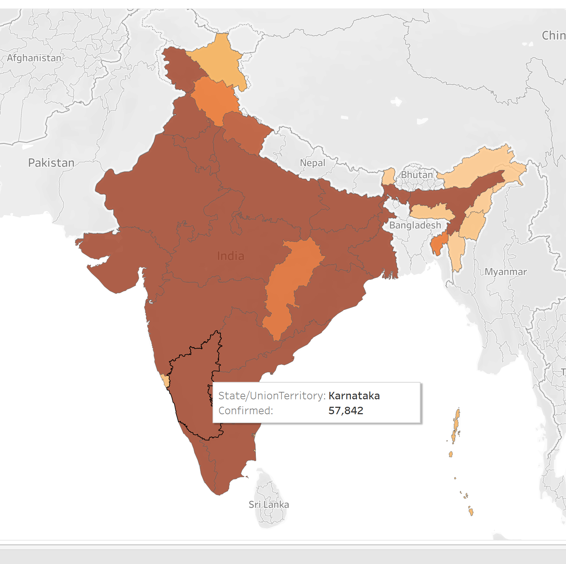

**In Karnataka:**

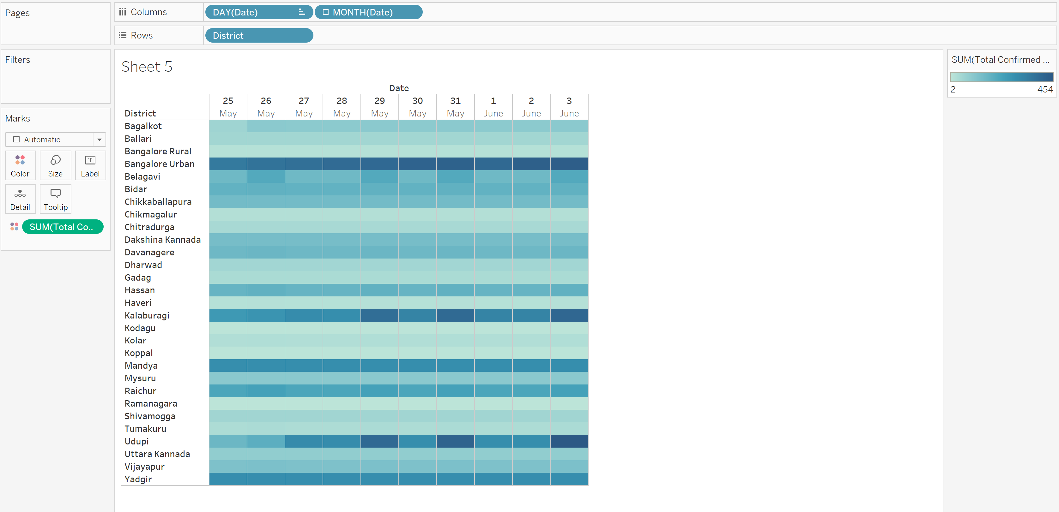

**Hotspots:** Bangalore urban, Kalaburagi and Udupi